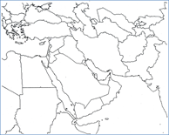Middle East Map Assignment NAME:
Directions:
- Label the following countries on your map:
Egypt Yemen Oman UAE Qatar Bahrain Kuwait Iran Iraq Turkey Jordan Israel Lebanon Syria Saudi Arabia
_____ /5 Points

- Color the (labelled) countries different colors (no two of the same colors next to each other)
- Label the following bodies of water and color them blue.
Mediterranean Sea Red Sea Arabian Sea Gulf of Oman Persian Gulf Caspian Sea Euphrates River Tigris River
_____ /5 Points

- 1 detailed paragraph on bottom of this page—what are the most important strengths and weaknesses of this map based on ethnic groups and religions? Incorporate information from the map activity for full credit.
______5 Points

_____ /15 Points Total

Middle East Map

