Name: Date:

The Human Brain: Write a bullet point description of each part’s functions.

#4: Cerebrum—Fill in the four lobes on the second page.
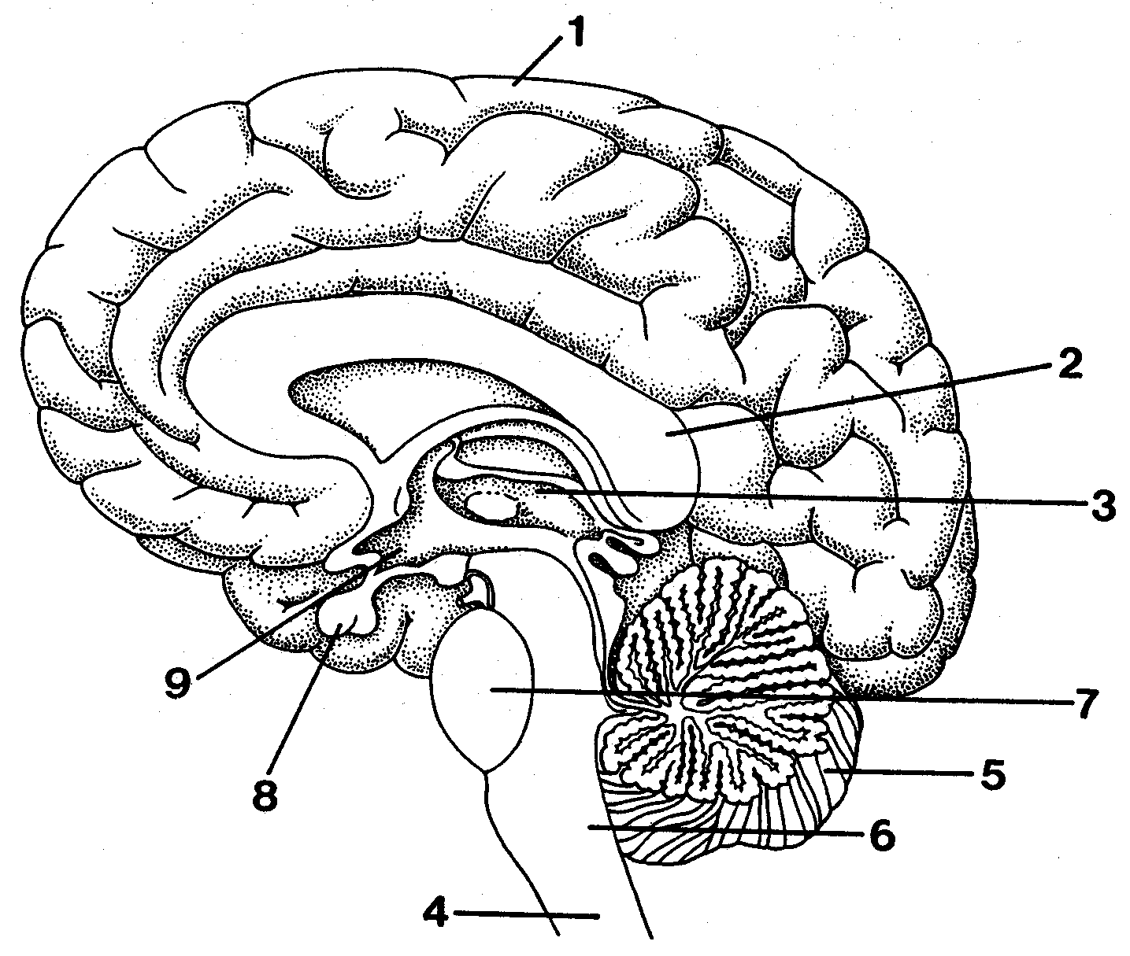
#5:
#1:
Leave Blank

Leave Blank

Leave Blank
#2:
#3:

#6:

# | Name | What is it in charge of? | Picture/Symbol
 | Cerebrum | Complete Lobe Descriptions on Next Page | BLANK

Brain Lobes: Fill in a bullet point description of what each lobe does.

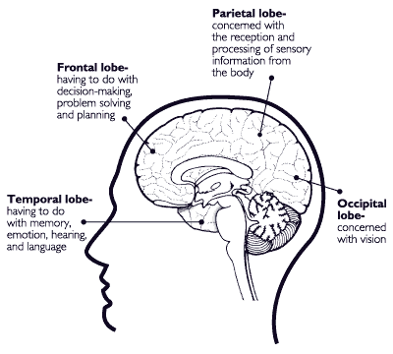
Temporal Lobe
Frontal Lobe
Parietal Lobe
Occipital Lobe

